*80%*

*Using your textbook, labs and the internet complete the following test in 1 hour 30 minutes or less. All code submitted must be your original work.*

1. [60 pts] Write a GUI application that looks up contact information by first or last name.

**Program must store this table in three parallel arrays or lists and use an appropriate loop.**

|  |  |  |
| --- | --- | --- |
| **First Name** | **Last Name** | **Phone Number** |
| Markel | Diggory | 555-8390 |
| Luiza | Gunnar | 555-4618 |
| Bryony | Hester | 555-4440 |
| Giraldo | Addy | 555-1687 |
| Lowri | Hari | 555-7763 |

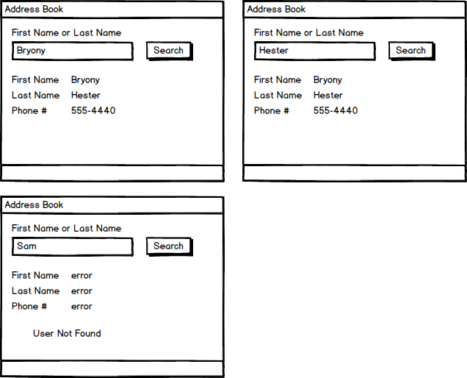

**Grading**

EX1 – Controls are laid out as expected – **4 pts**

EX1 – Controls names follow naming conventions – **3 pts**

EX1 – Variable names follow naming conventions – **3 pts**

EX1 – Program uses the arrays or lists to search and display the data– **5 pts**

EX1 – Program uses a single loop to search for users – **5 pts**

EX1 – Failed searches display all expected error messages – **5 pts**

EX1 – User can search for a user by first name – **5 pts**

EX1 – User can search for a user by last name – **5 pts**

EX1 - User should be able to perform a case-insensitive search **- 5pts**

EX1 - User should be able to perform partial searches (Mark for Markel) - **5pts**

EX1 – Program displays the first name of the found user – **5 pts**

EX1 – Program displays the last name of the found user – **5 pts**

EX1 – Program displays the phone number of the found user – **5 pts**

1. [40 pts] Write a console application that allows the user to enter the price of all the items in their shopping cart, and then computes the total cost of those items:
   * Prompt the user for prices until they enter zero
   * If the user enters a price that is greater than zero
     + Accept the price
     + Prompt the user for another item
   * If they enter price that is less than zero
     + Ignore the price
     + Display an error message
     + Prompt the user for another item
   * If the user enters a price of zero
     + Ignore the price
     + Do **not** display an error message
     + Display the **number of items purchased, the average price per item, the subtotal, the total tax (8%), and the grand total**
     + Stop the program

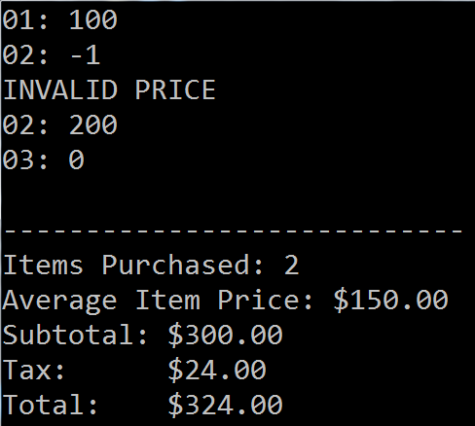

**Program must use appropriate loop(s).**

EX2 – Program accepts valid prices – **5 pts**

EX2 – Program rejects invalid prices – **5 pts**

EX2 – Program stops only when zero is entered – **5 pts**

EX2 – Program displays the number of items purchased accurately – **5 pts**

EX2 – Program displays the average price per item accurately – **5 pts**

EX2 – Program displays the subtotal (before tax) accurately – **5 pts**

EX2 – Program displays the total tax accurately – **5 pts**

EX2 – Program displays the grand total (after tax) accurately – **5 pts**